# hires_header.png

As complexity increases with the incremental adoption advanced technologies and features, pre-launch testing becomes even more critical to the commercial success of new devices. Testing will also becomes more expensive.

GCF Certification is the most cost-effective way for a manufacturer to demonstrate the interoperability and conformance of its new devices.

As the diversity of devices expands, GCF Certification will also gain relevance and wider acceptance in vertical sectors and open market distribution channels.

# Why are device manufacturers members of GCF?

### How does GCF Certification benefit MANUFACTURER?

* SPACE FOR MEMBER TO INCLUDE OWN DATA FOR INTERNAL USE
* SPACE FOR MEMBER TO INCLUDE OWN DATA FOR INTERNAL USE

**How does GCF benefit manufacturers?**

* Globally recognized benchmark of interoperability between mobile devices and operator networks
* Identifies a device as being relevant to multiple operators in multiple markets
* Harmonisation of testing provides:
  + Confidence in, and comparability of, test results
  + Economies of scale and a competitive market in the supply of test tools and services
  + A reduction in cumulative testing costs for manufacturers

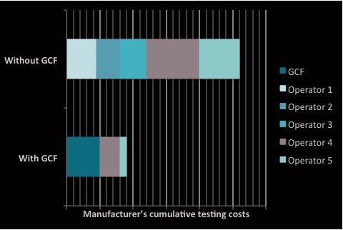

* Defines the boundary between the testing responsibilities of manufacturers and operators
* Supports commercialisation and shortens time-to-market for important new technologies by achieving industry consensus on the most appropriate, effective testing
* Automatically alerts GCF’s entire operator membership to newly certified devices: test results can be accessed by any interested GCF Operator member
* Certified devices included in public listing

**What is GCF Certification?**

* A common baseline for assessing the interoperability between mobile devices and Operators’ networks and services
* An eco-system of technical experts from leading device manufacturers, operators and the test industry with a shared commitment to harmonising the scope and means of device testing
* Focuses on testing core functionality of a device and its compliance with the industry standards
* Combines conformance, interoperability and field testing to provide real-world evaluation of a device’s performance
* Assurance of interoperability underpins roaming
* Supported by leading operators with interests in markets worldwide

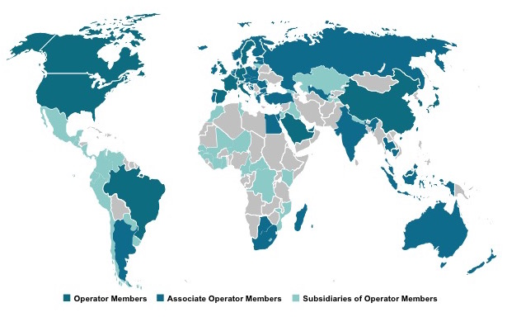

* Use of accredited Test Houses promotes confidence
* Provides economies of scale and drives efficiencies that benefit Operators and OEMs
* Evolves in line with the needs of the industry
* A certified device will:
  + Deliver services that meet the expectations of Operators and their end-users
  + Help prevent manufacturer or operator brands being damaged by poorly performing devices
* 536 devices (including 89 modules) certified by 53 manufacturers in 2014