# hires_header.png

As device complexity increases with the incremental adoption of advanced technologies and features, pre-launch testing becomes even more critical. It also becomes more expensive.

GCF Certification is the most cost-effective way of assuring that devices will support operator services and meet the expectations of end-users. Operator input into GCF certification criteria also facilitates interoperability between operators’ networks.

As the diversity of devices expands, GCF Certification will gain relevance and wider acceptance in vertical sectors and open market distribution channels.

# Why are operators members of GCF?

### How does GCF Certification benefit OPERATOR NAME?

* SPACE FOR MEMBER TO INCLUDE OWN DATA FOR INTERNAL USE
* SPACE FOR MEMBER TO INCLUDE OWN DATA FOR INTERNAL USE

**What is GCF Certification?**

* A common baseline for assessing the interoperability between mobile devices and operators’ networks and services
* An eco-system of technical experts from leading device manufacturers, operators and the test industry with a shared commitment to harmonizing the scope and means of device testing
* Focuses on testing core functionality of a device and its compliance with the industry standards
* Combines conformance, interoperability and field testing to provide real-world evaluation of a device’s performance
* Assurance of interoperability underpins roaming
* Supported by operators with interests in markets worldwide

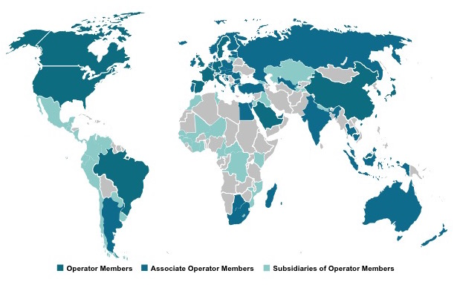

* Managed by OEMs
* Testing undertaken in accredited Test Houses
* Results available for audit by any interested operator
* Provides economies of scale and drives efficiencies that benefit operators and OEMs
* Evolves in line with the needs of the industry
* 536 devices certified by 53 manufacturers in 2014
  + Almost all flagship smartphones launched by major manufacturers in 2014 were certified

**How does GCF benefit operators?**

* Globally-recognized benchmark of interoperability between mobile devices and operator networks
* Identifies mobile devices that meet operator’s needs
* Harmonisation of testing:
  + Provides comparability of test results
  + Generates economies of scale and a competitive market in the supply of test tools and services
  + Raises confidence of operators in product quality
* Operators do not need to repeat GCF tests and can focus their own resources in areas that add value to their own customers and differentiate their offering from competitors

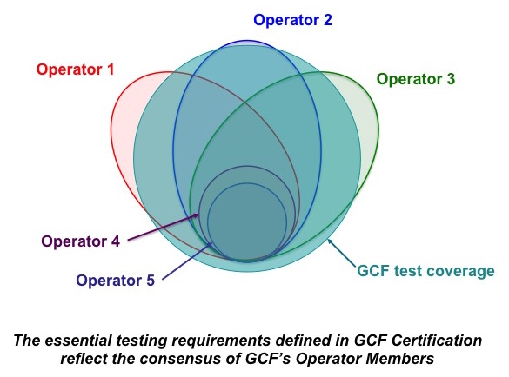

* GCF allows operators who actively test devices to reduce their internal testing costs by as much as 80%
* Simplifies the approval process for devices to be sold directly
* Helps operators identify devices to recommend for sale through indirect sales channels
* Offers a level of assurance about the performance of Open Market devices
* Supports the commercialization of advanced technologies and features by achieving industry consensus and interaction with bodies such as 3GPP, GSMA etc